Akuru website is under active development. Read more>>

From the inception of Akuru Collective did not have a website and been operating on

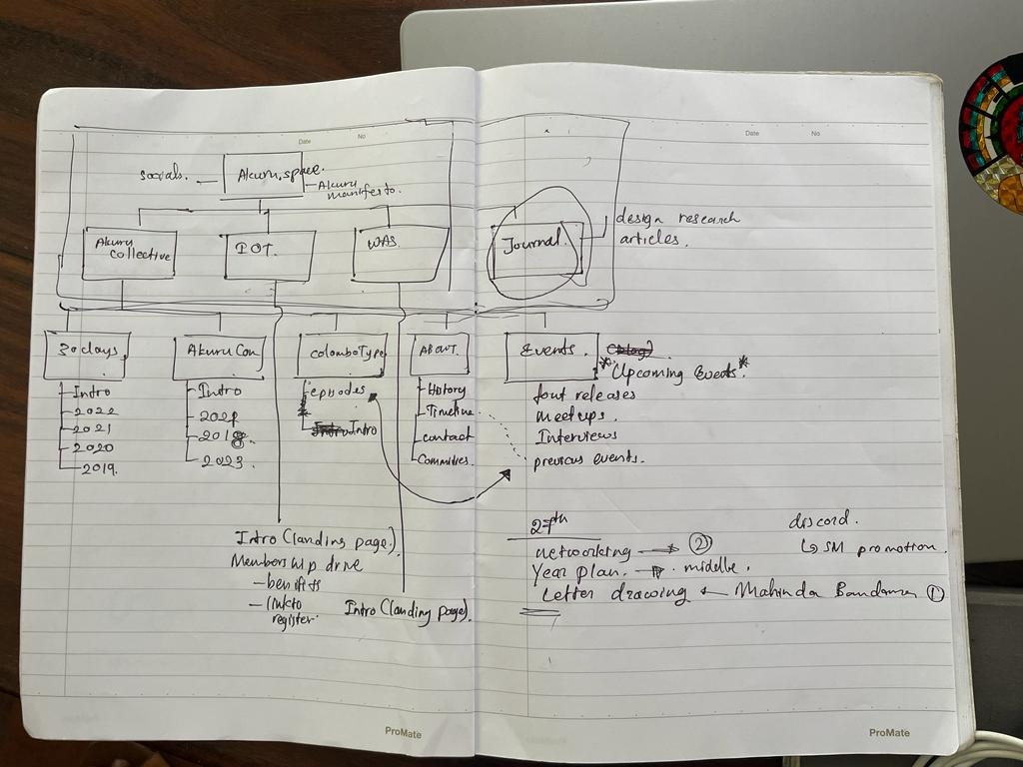

reads
- short
- medium
- long
- collections

watch / videos
- Akuru YT Library

learn
- courses

research
- typography
- calligraphy
- history
- graphic design
- Bibliography on Sinhala typography

30 Days of Akuru

participate
- Events
collective

Events | Knowledge | About | News
30 Days of Akuru  - 2019 ✔️  - 2020 ✔️  - 2021  - 2022  - 2023  - 2024 | Articles  - Short  - Medium  - Long | History  - About us  - Timeline  - Committee  - Contact us
AkuruCon  - 2018  - 2021  - 2023 | Research  - Academic papers (Bibliography) | WAS Museum  - WAS
ColomboType  - Colombo Type #001  - Colombo Type #002  - Colombo Type #003 ✔️  - Colombo Type #004 ✔️  - Colombo Type #005 ✔️ | Discussions  - YT video playlists  - | IOT
Knowledge exchange  - Typography for Children ✔️  - Lanka Typography Educators Forum 2017 ✔️  - Letters Lanka ✔️  - ATypI working Seminar Conference In Colombo ✔️ |  | Community Guidelines
Happenings
- Woodtype Cleanup ✔️
- Sinhala Font Developers meeting ✔️
- International Mother Language Day ✔️
- Akuru Movie Night ✔️
- Akuru Celebrating Literary Month ✔️

- Four main menus (Events, Resources, About, IOT)
- Sub-areas (dropdowns) under main menus
- Articles - Magazines / Journal structure looking
- Latest in knowledge
- News Section on Homepage

CONTENT
https://drive.google.com/drive/folders/14FNE60iboSR-6eJ5iGAd1f40PJ5Khf8T

HISTORY

Description

Akuru is a collective of people coming together to inspire interest in language, typography and literature. The Akuru Collective is a not-for-profit organisation that belongs to all of our members. We function with the key objective of nurturing talent and building an efficient and meaningful service to the people interested in typography, writing systems, languages and literature of South Asia and Southeast Asian regions.

- History
Akuru Collective’s story starts with a chance encounter between Pathum Egodawatta and Dr. Sumanthri Samarawickrama at a Typography conference in India. When these two strangers first shared their common interest on the subject, they also shared their common vision to encourage typography in Sri Lanka. Their vision came true in 2017 when Sri Lanka hosted the first Type related conference ‘TypoDay’, a typography conference coordinated by Industrial Design Centre (IDC), Indian Institute of Technology Bombay (IIT Bombay) with support from India Design Association (InDeAs) and Aksharaya. In the 2017, Department of Integrated Design, University of Moratuwa, Sri Lanka collaborated with the organizers in marking its 10th anniversary, for the first time, this conference stepped out of Indian soil. Under the conference theme ‘Typography and Diversity’, the context of culture, multilingual scripts, the native and indigenous scripts were discussed to a large audience of 70% being international. It was also the first time when all the type lovers of Sri Lanka got to connect with each other and share their enthusiasm. This small type community would later become ‘The Akuru Collective’, a team of type enthusiasts who got together for the Love of Type.

The Akuru Collective started with organizing monthly mini-events titled ‘Colombo Type Meetup’. These mini events included talks and workshops conducted by pioneers in the field of design who contributed to type and typography in the country. The objective of these meetings were to build awareness and strengthen the type community. It is still one of the most anticipated events in Akuru monthly calendar.

In 2018, the Akuru Collective compiled a manifesto to define its aim and objectives and as a result Sri Lanka’s first homegrown type conference ‘AkuruCon’ came to light. This event built stability and visibility among several stakeholders; the Department of the National Archives, Island’s many Design schools and the Embassy of the Netherlands to name but a few. The event included workshops and discussions on all relevant aspects of letters: Calligraphy. Lettering, Typography and Font making. Akuru envisioned continuing this conference as a bi-annual event.

Parallel to AkuruCon 2018, Akuru Collective launched the ‘Galle Project’ to revive typefaces of the Dutch Press in Ceylon. When the first modern printing press was established in Ceylon (Sri Lanka) in 1700s by the Dutch colonials, Sinhala script had their first opportunity to be printed using the modern printing techniques. This had marked a significant transition of Sinhala letter forms which had been written on palm leaves up until then. The Galle Fonts Project is about examining and conserving this design transformation as a shared cultural heritage. The project was initiated by Mooniak, a local type design studio in collaboration with Akuru Members.

In 2019, with the initiation of Gerry Leonidas, ATypI announced the relaunch of ATypI Working Seminars and the ATypI team together with the Akuru Collective, FARU (Faculty of Architecture Research Unit), University of Moratuwa, Sri Lanka, hosted ATypI Working Seminars Colombo on the 22-23 March 2019 as a single track two-day event. The Working Seminar Colombo was the first Working Seminar in 27 years for ATypI, and certainly the first of its kind in the region with an exclusive focus on teaching typography. Raising ATypI’s profile in Sri Lanka and the region was a key benefit, and is certain to lead to future local initiatives.

Akuru had identified a lack of Unicode compliant fonts in Sri Lanka. The limited market size does not encourage foundries to make an investment in the market. To counter this problem with the initiation of Pathum Egodawatta, the Akuru Foundry was established to motivate amateur type designers to design and release their font. Akuru Foundry is set up as a community cooperative organization owned by the members of the collective and all fonts are released under free and open source fonts for public use.

Along the way, Akuru COllective has also been able to promote and encourage love of type in all communities through online opportunities as #30DaysofAkuru 2019 & 2020. #30DaysofAkuru is organized by Letters.Lanka, a project initiated by a group of Akuru members. It is for anyone interested in creating Sinhala and Tamil letters. The event so far, has been a massive success with over 1000 entries.

In late 2018, Akuru came across W.A. Silva foundation, a team dedicated to pass on the legacy of renowned Sri Lankan author W.A. Silva and to continue his great national mission towards language and literature of the Island. W. A. Foundation had preserved the house “Silvermere” in Wellewatte, Colombo where Silva lived, as a national treasure and thereby had established a Language-Literature Museum. Sharing their passion for language and printing, Akuru found an inspiring space at Silvermere, for Colombo Type meetups and similar events. Thus, started the continuing collaboration between Akuru and W.A. Silva foundation- partners in promoting language, literature and letters in Sri Lanka. In 2019 September, W.A. The Silva Museum became the home to Akuru.
In 2020, Institute of Typography was established as the legal guardian and patron to Akuru. Institute of Typography is Sri Lanka's first institution for research, development and education of typography, font design, letters and related fields.

Within a short period of only three years Akuru had come a long way, and yet, a long way ahead. Akuru warmly welcomes anyone with a passion for typography and letters to come along the journey.

The words etched on the surface hold the power to make or break this world: ‘Akuru’ sees this power, and looks to understand it better, so that we may share it, use it and surmount it.

- Akuru Manifesto -

Community Guidelines*

Akuru Collective Community Guidelines

Welcome to Akuru!
We are a community based on trust, transparency, and contribution. We provide a safe and inclusive space to discuss typography, fonts, lettering and other related design fields . We want everyone to be a part of our community and have their voice heard. In order to do so, we expect everyone to act in accordance with these guidelines.

Let us be authentic
Be an authentic and active member in our community. In doing so, you contribute to the health and longevity of this community. We are a collective of unique people, we encourage each of you to bring your own different point of view to strengthen our community.
Let us be honest
Please act respectfully & honestly. Be honest within the community and provide your genuine ideas and feedback , and be mission-aligned with each other.
Let us be respectful
Refrain from communicating in a defamatory, indecent, offensive, profane, discriminatory, misleading, unlawful or threatening manner within the community. We have zero tolerance for unacceptable behavior.

Unacceptable behaviors include: spamming, trolling, intimidating, harassing, abusive, discriminatory, derogatory or demeaning speech or actions by any participant in our community online, at all related events and in one-on-one communications carried out in the context of community business.

Harassment includes: harmful or prejudicial verbal or written comments related to gender, sexual orientation, race, religion, disability; inappropriate use of nudity and/or sexual images (including presentation slides); inappropriate depictions of violence (including presentation slides); deliberate intimidation, stalking or following; harassing photography or recording; sustained disruption of talks or other events; inappropriate physical contact, and unwelcome sexual attention.
Let us be Inclusive
Akuru Collective welcomes members regardless of their age, education, location, ethnicity, religion, language, political opinion and worldview. Whoever you are, Akuru believes, you have a unique perspective and skillset to contribute. We do not tolerate members holding other’s differences against them. Be welcoming to all those who want to contribute genuinely with their talents and perspectives.
Let us be mindful
Please be mindful that other people in the community have had different life experiences and may have a different perspective to yours. We welcome different viewpoints.

Our members are often volunteers taking time away from their families or free time to grow our collective. Please be mindful of their time, be patient and respectful when collaborating.
Let us speak up
If something’s wrong, let us know. We believe in self-managing systems, so we don’t police or moderate excessively. We still rely on you to let us know when something isn’t right.
Let us share love
Collaborate, share new knowledge & skills among the community, be open to giving and receiving constructive criticism . It will help us all grow as a community.

These guidelines will continue to evolve as we grow. It’s up to all of us to build an honest, safe and trustworthy community.

Partners and Sponsors*

